NAAN MUDHALVAN PROJECT DOCUMENTATION

Student Enrollment & Course Management
System (SECMS)

Submitted by,
Team members Name : Gunasri.P, Akshiya.A, Vithya.V, Deepa.S
Department : Bachelor of computer Application
Year : 3rd yr
College : Krishnasamy college of science,arts and management for women

Submitted To,
Naan Mudhalvan Pogram
Acadamic Year : 2025-2026

User Story:
The Student Enrollment and Course Management System is a Salesforce-drivenapplication designed to enhance and automate the management of academic enrollmentprocesses in educational institutions. The system provides a centralized platform whereadministrators, enrollment officers, and instructors can efficiently maintain student data,manage course offerings, process enrollments, assign instructors,track payments, andgenerate reports. By integrating these operations within a single Salesforce environment,the system improves efficiency, data accuracy, and overall academic administration.

1. INTRODUCTION

1.1 Project Overview :

The Student Enrollment & Course Management System is a cloud-based application
management. developed using Salesforce to manage student academic activities efficiently
.The system helps educational institutions organize and maintain information about
students,courses,instructors, and enrollments in a structured manner.Through this system,
administrators and enrollment officers can easily register students,manage course details,
assign instructors and monitor enrollment activities
By using Salesforce reports and dashboards, management can track important data such as
student enrollments, course demand, instructor assignments, and fee payments. This
system reduces manual work and improves the accuracy of academic operations

1.2 Purpose :

The pupose of this project is to build a digital asystem that simplifies the student
enrollment process.Many institutions still manage enrollment data manually using
speadsheets.

Automated enrolment proccesing
Secure access control for different users
Real time reports and dashboards

2. IDEATION PHASE
2.1 Problem Statement (Customer Problem Statement Template)

PS | I am  (Customer) | I’m trying  to | But | Because | Which makes me  feel
PS-1 | Enrollment  Officer | manage student enrollments records | data is stored in different places | Manual systems are used | Stressed and time consuming
PS-2 | Administrator | Monitor course registration and revenue | Reports are not generated | data is not centralized | Difficult to make decisions

2.2 Empathy Map Canvas User Persona: Enrollment Officer
- Think & Feel: Wants to manage student enrollments without mistakes
- Hear: Complaints from students about delays.
- See: Multiple spreadsheets and manual records.
- Say & Do: checks records repeatedly to avoid errors.
- Pain: Duplicate entries and slow approval process
- Gain: Automated,system with dashboards quick approvals

2.3 Brainstorming & Idea Prioritization
Step 1 – Brainstormed Ideas
- Spreadsheet-based tracking system
- Web-based enrollment portal
- ERP system integration
- Salesforce-based management system

Step 2 – Grouping
- Semi-automated solutions
- Manual solutions
- Fully automated cloud solutions

Step 3 – Prioritization
Salesforce-based SECMS was selected due to high feasibility and high impact.

3.REQUIREMENT ANALYSIS PHASE
3.1 Customer Journey Map Stages covered:
- Student registration
- Course Exploration
- Enrollment Request
- Payment Verification
- Approval Process
- Instructor Allocation
- Monitoring & Reporting

3.2 Solution Requirements
Functional Requirements

FR No | Epic | Description
FR-1 | Student Management | Maintain student profiles
FR-2 | Course Management | Create and update courses information
FR-3 | Enrollment Mangement | Process course enrolment requests
FR-4 | Instructor Allocation | Assign instructors
FR-5 | Reporting | Dashboards and reports

Non-Functional Requirements

NFR-1: Usability
The application should provide a user-friendly interface that allows users to easily navigate between different modules and perform tasks with minimal training.
Examples:
- Role-based dashboards
- Quick student registration form
- One-click enrollment approval

NFR-2: Security
The system must protect sensitive student information by implementing authentication and role-based access control.
Examples:
- Instructors view only assigned students
- Only admins can modify course details
- Students cannot access other student records

NFR-3: Reliability
The system should perform consistently without errors during enrollment processing and data updates.
Examples:
- No duplicate course registration
- Accurate status updates after approvals
- Consistent report generation

NFR-4: Performance
The application should provide quick response times even when handling a large number of student records.

Examples:
- Fast search for student records
- Quick dashboard refresh
- No lag during bulk uploads

NFR-5: Scalability
The system must supp number of students, c 'uture growth in the ↓ s, and departments
Examples:
- Extend to mobile or portal integration
- Add new departments without redesign
- Handle increased admissions annually

NFR-6: Availability
Users should be also to access the system online with minimal downtime during operational hours
Examples:
- Reliable during peak admission season
- Automatic backup of student records
- 24/7 cloud access

3.3 Data Flow Diagram
- User inputs student and enrollment data
- System validates and stores records
- Approval process routes data
- Project planning tables
- Solution architecture
- Reports and dashboards consume processed data.
The system processes enrollment requests, routes approvals, validates data, assigns instructors, and generates reports.

3.4 Technology Stack
Layer | Technology
UI | Salesforce Lightning experience
Logic | Salesforce Flows builder
Database | Salesforce custom Objects
Automation | Validation Rules and Approval Process
Reporting | Reports and Dashboards

4. PROJECT DESIGN PHASE
4.1 Problem–Solution Fit
Many educational institutions still rely on manual methods such as spreedsheets,emails and paper records to manage student enrolment and course information.

The application allows administrators to maintain student records, create and manage course information, assign instructors, and monitor enrollment requests. Automation tools available in Salesforce help reduce manual effort by validating data, triggering workflows, and handling approval processes.
The system also supports reporting and dashboard features, enabling management to analyze important metrics such as course registrations, student activity, and fee collections

4.2 Proposed Solution
Functional Requirements

Parameter | Description
Problem | Manual handling of enrollment data
Solution | Cloud based system built on Salesforce
Novelty | Automated workflows
Impact | Improved student experience
Revenue Model | Institutional deployment
Scalability | Multi-department support

- Project Development Phase:
Project Flow:

Milestone 1: Salesforce Developer Account Creation
Milestone 2: Custom Object Creation (Student, Course, Enrollment, Instructor)
Milestone 3: Tabs Creation
Milestone 4: Lightning App Creation
Milestone 5: Fields Creation
Milestone 6: Create Relationships
Milestone 7: Page Layout Customization
Milestone 8: Validation Rules
Milestone 9: Flows (Automation)
Milestone 10: Approval Process
Milestone 11: Reports
Milestone 12: Dashboards
Milestone 13: Security Setup
Milestone 14: Conclusion

What you'll learn
- Real-time Salesforce project implementation
- Designing custom objects and relationships
- Creating page layouts & record types
- Writing validation rules
- Building automation with flows
- Creating approval workflows
- Developing reports & dashboards
- Setting up security with profiles, permission sets, and sharing
- End-to-end application testing
Milestone 1-Salesforce :
Activity 1: Creating Developer Account:
Creating a developer org in salesforce.
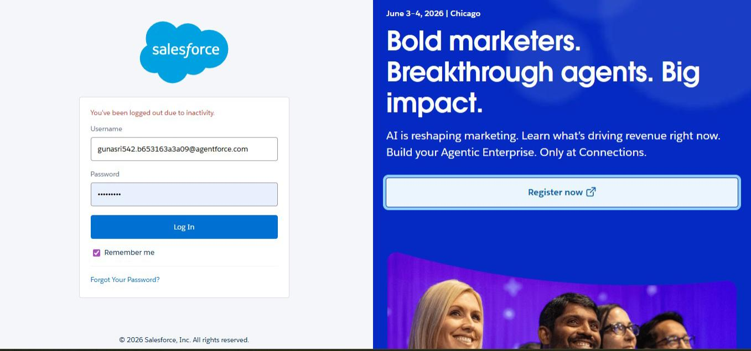
Go to https://developer.salesforce.com/signup
On the sign up form, enter the following details :

First name & Last name
Email
Role : Developer
Company : College Name
County : India
Postal Code : pin code
Username : should be a combination of your name and company This need not be an actual email id, you can give anything in the format :
username@organization.com
I used gunasri542@gmail.com
Click on sign me up after filling these.

Activity 2: Account Activation:

- Go to the inbox of the email that you used while signing up. Click on the verify account to activate your account. The email may take 5-10mins.

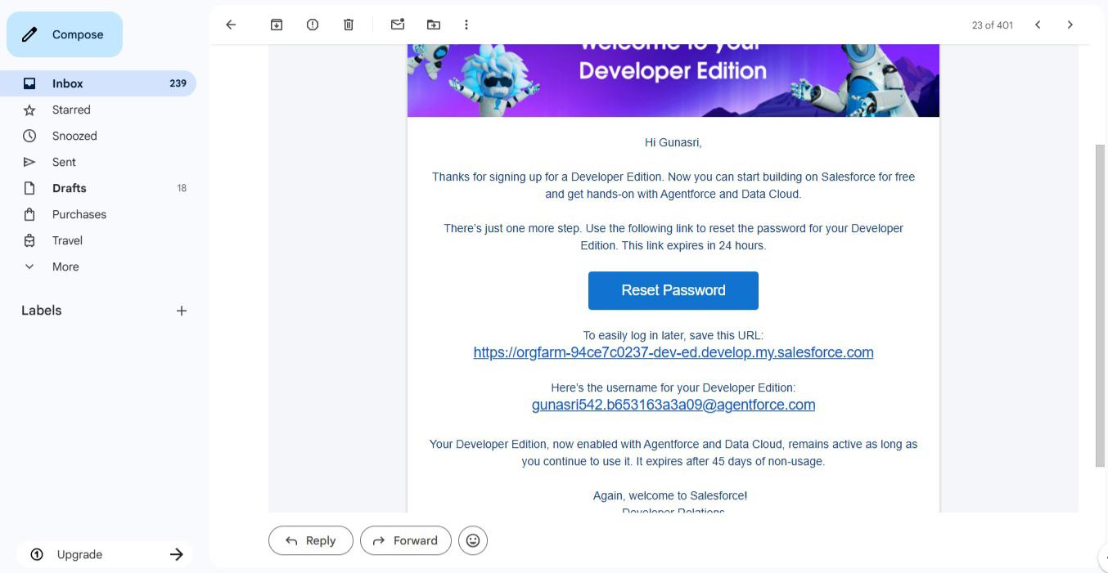

- Click on Verify Account
- Give a password and answer a security question and click on change password.
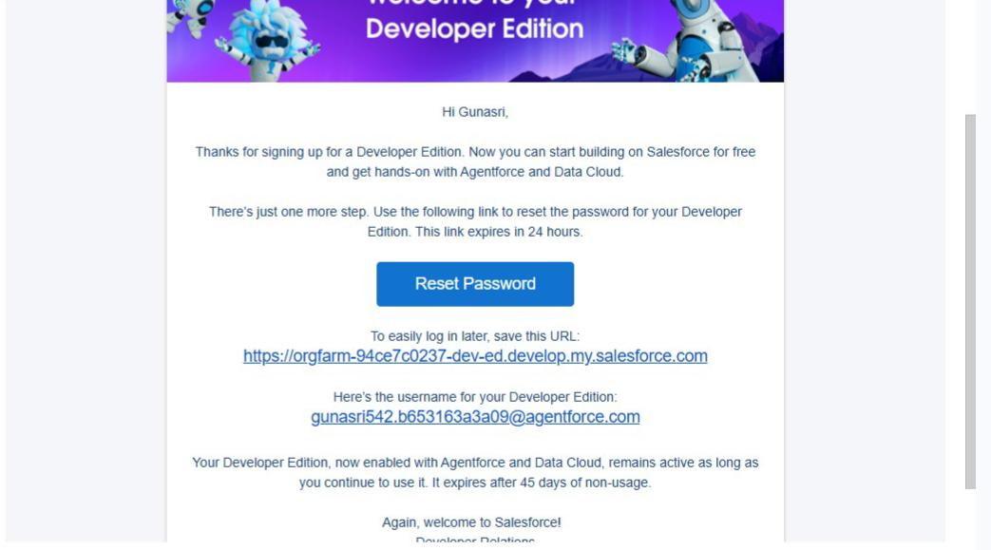

- Then you will redirect to your salesforce setup page.
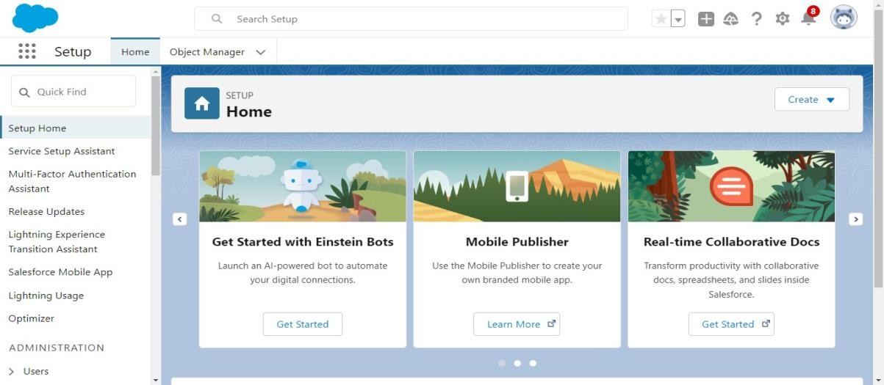

Milestone 2 – Objects:
Activity 1: Creating Student Object:
The purpose of creating the Student custom object is to store and manage information about students such as their personal details, contact information, and enrollment status.

To create the Student object:

Go to the Setup page.

Click on Object Manager.

Click on Create → Custom Object.

Enter the details as below:
  - Label: Student
  - Plural Label: Students
  - Object Name: Student
  - Record Name: Student Name
  - Data Type: Text
  - Under Optional Features, select:
  - Allow Reports
  - Allow Activities (optional but recommended) 9. Track Field History (optional, if you want)
  - Under Search Status, select:
  - Allow Search
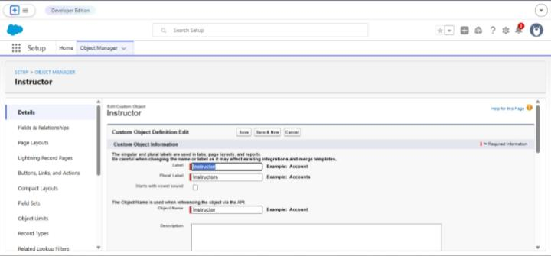
  - Click Save.

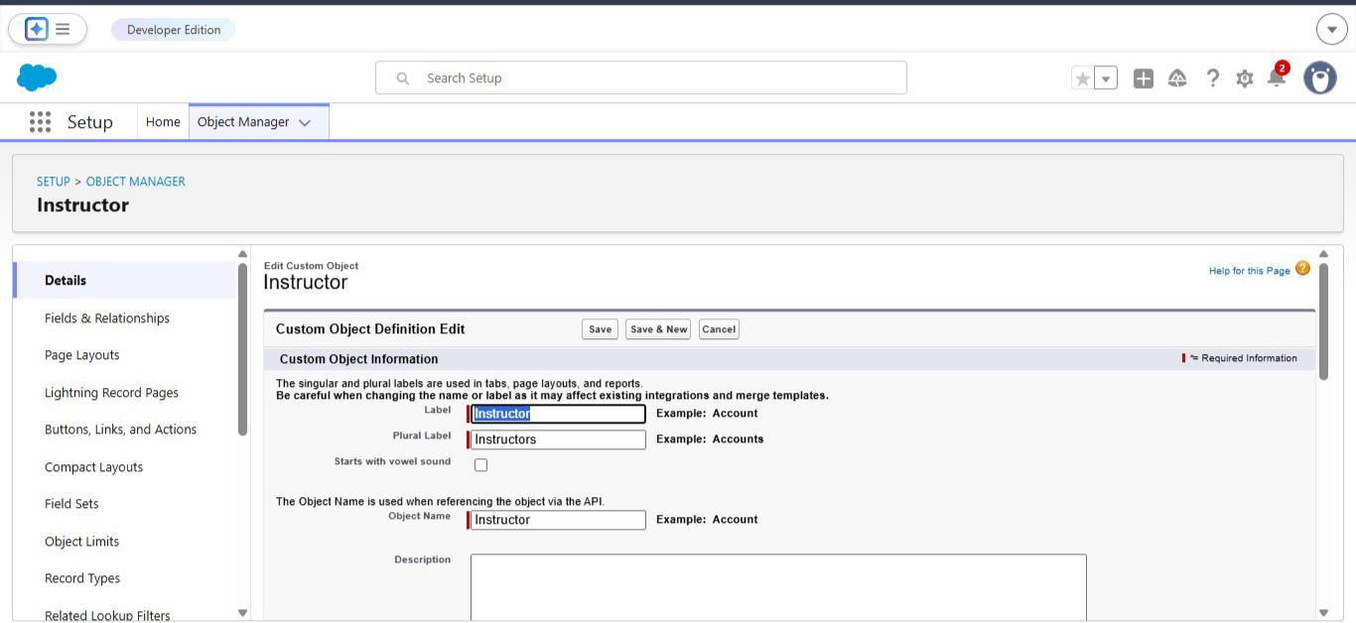

In the same way Create Courses, Instructors, and Enrolments objects

Milestone 3 - Fields:

Table 1: Student Object Fields:

Field Label |  | Data Type
Student Name |  | Text  (Standard)
Email |  | Email
Phone |  | Phone
Date of Birth |  | Date
Student Status |  | Picklist
Address |  | Text Area
Field Label | Data Type
Course  Name | Text  (Standard)
Category | Picklist
Duration | Number/Text
Course Fee | Currency
Description | Text Area
Field Label | Data Type
Instructor  Name | Text  (Standard)
Instructor  Code | Text
Table 2: Course Object Fields:

Table 3: Instructor Object Fields:

Expertise | Picklist
Phone | Phone
Email | Email

Table 4: Enrollment Object Fields:

Field Label | Data Type
Student | Lookup  (Student)
Course | Lookup (Course)
Instructor | Lookup  (Instructor)
Enrollmen t Date | Date
Enrollmen  t Status | Picklist
Fees Paid | Checkbox
Total  Amount | Currency
Comment  s | Text Area

Milestone 4 – Create Relationships:
- Activity 1: Create Lookup from Enrollment to Student:

Go to Setup → click Object Manager.
- Type Enrollment in Quick Find → click Enrollment__c object.
- Click Fields & Relationships → click New.
- Select Lookup Relationship → click Next.
- For Related To, select Student__c → click Next.
- Enter Field Label: Student (API Name: Student__c).
- Click Next through Field-Level Security and Layout options (ensure it’s visible and added to layout).
- Click Save.
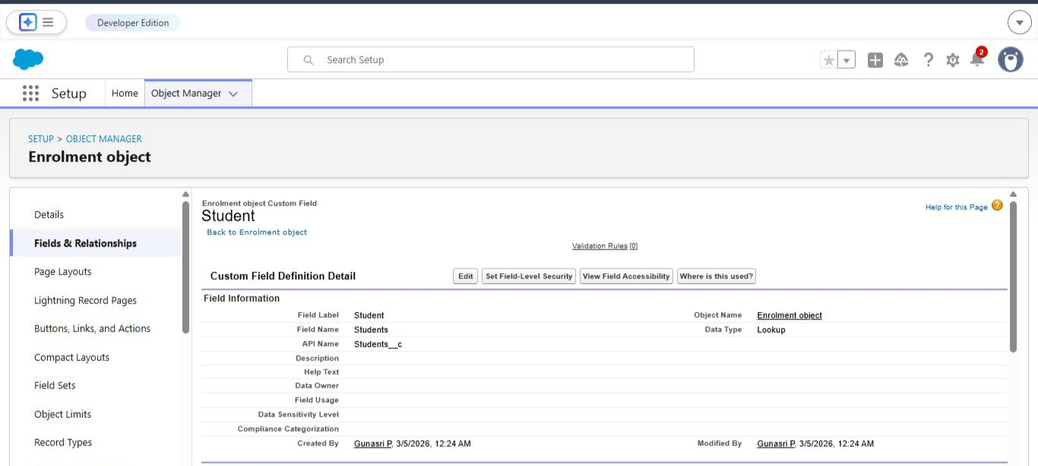

Activity 2: Create Lookup from Enrollment to Course
Purpose:
To link each Enrollment to a Course.

Steps:
- Go to Setup → Object Manager → Enrollment__c.
- Click Fields & Relationships → New.
- Select Lookup Relationship → Next.
- Related To: select Course__c → click Next.
- Field Label: Course (API Name: Course__c).
- Click Next (set visibility and layout) → Save.
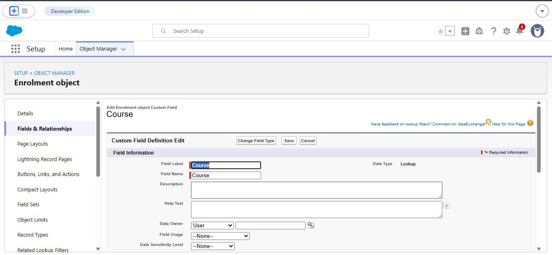
Activity 3: Create Lookup from Enrollment to Instructor:
Purpose:
To store which Instructor is assigned to a particular Enrollment.

Steps:
- Go to Setup → Object Manager → Enrollment__c.
- Click Fields & Relationships → New.
- Choose Lookup Relationship → Next.
- Related To: select Instructor__c → Next.
- Field Label: Instructor (API Name: Instructor__c).
- Complete Field-Level Security and Page Layout options → Save
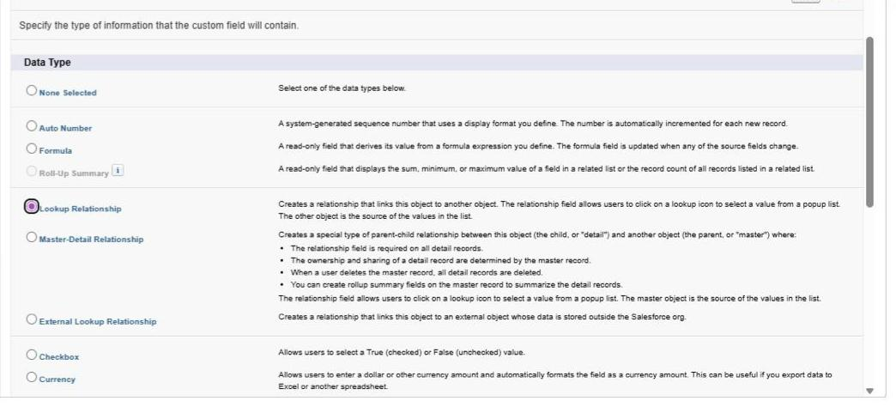
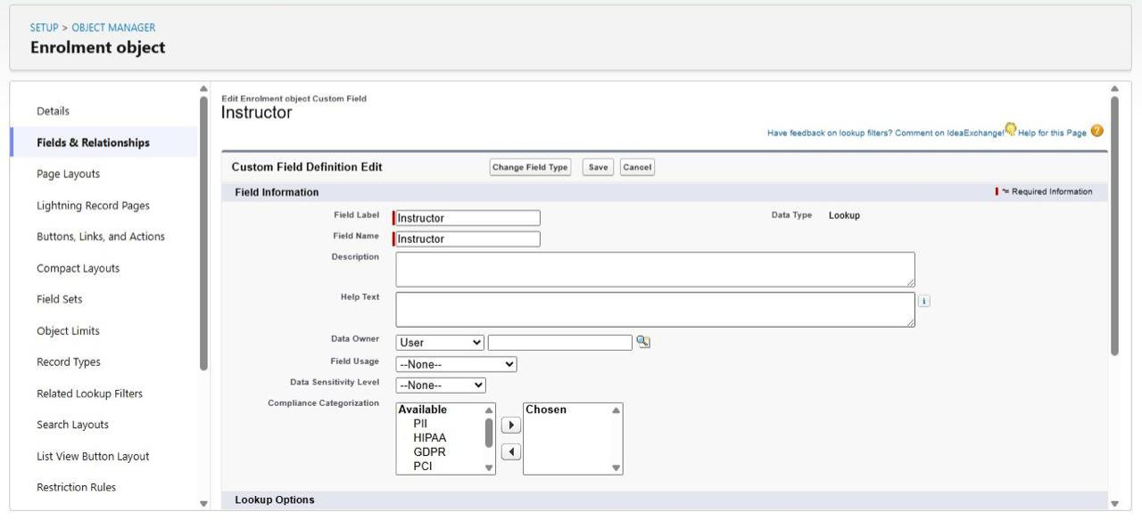

Milestone 5 – Validation Rules:

Activity 1: Student Email Domain Validation
Purpose:
To ensure students use only allowed institutional email addresses.

Steps:

Go to Setup → Object Manager → Student__c.
Click Validation Rules → New.
Rule Name: Student_Email_Domain_Validation.
Error Condition Formula: (example for @student.edu)
● NOT(CONTAINS(Email__c, "@student.edu"))

Error Message: Email must be a valid student institutional email.
Error Location: Field → Email__c. Click Save.
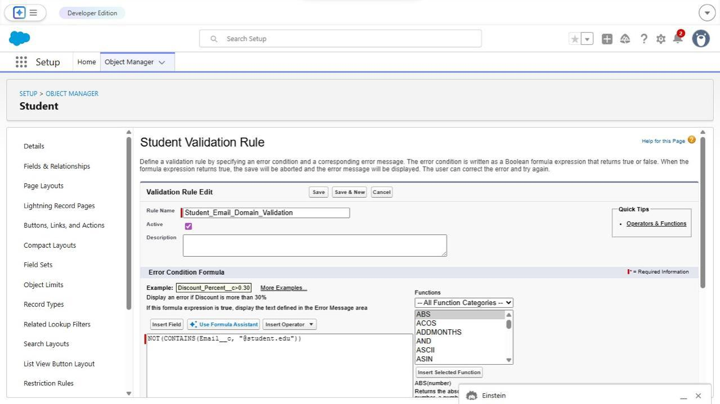
Activity 2: Fees Must Be Paid Before Approval

Purpose:
Prevent Enrollment from being approved until fees are paid.

Steps:

- Go to Setup → Object Manager → Enrollment__c.
- Click Validation Rules → New.
- Rule Name: Fees_Must_Be_Paid_Before_Approval.
- Error Condition Formula:
AND(
ISPICKVAL(Enrollment_Status__c, "Approved"),
Fees_Paid__c = FALSE
)
5.Error Message: Fees must be paid before approving an enrollment.
6.Error Location: Top of Page (or field as needed).
Click Save.
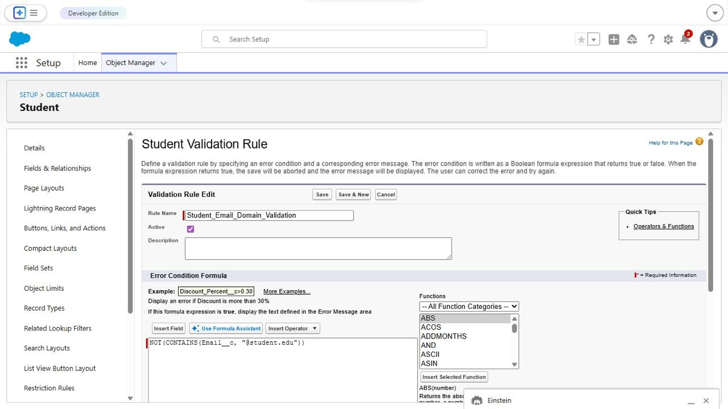

Milestone 6 – Approval Process

Activity 1: Create Approval Process for Enrollment Requests

Purpose:
Route Enrollment requests to Training Manager for approval or rejection.

Steps:

- Go to Setup → Approval Processes → select Enrollment__c.
- Click Create New Approval Process → Use Standard Setup.
- Process Name: Approval_Enrollment_Request.
- Entry Criteria: Enrollment_Status__c = "Requested".
- Save and configure steps.
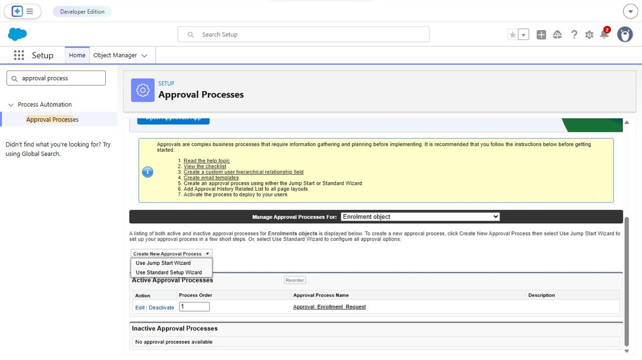
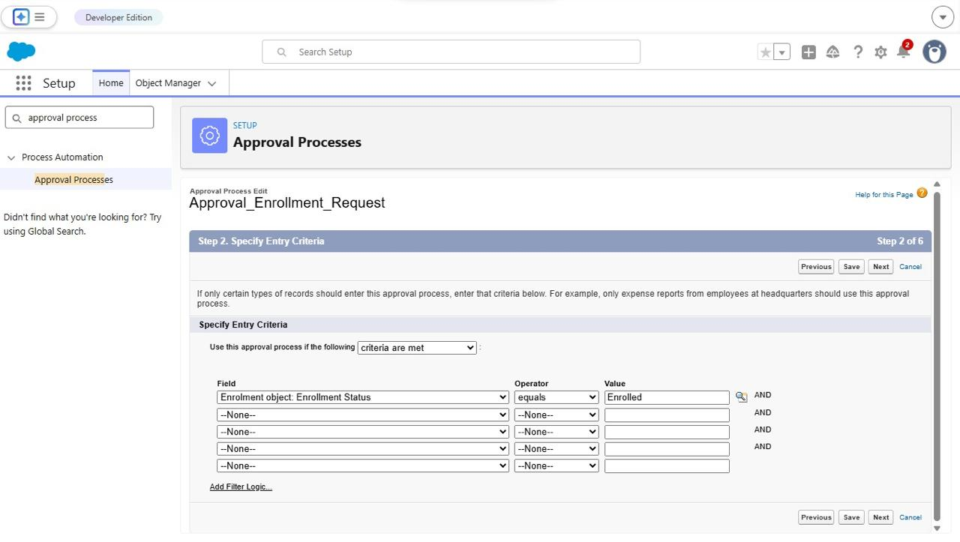
- Add Approval Step:
- Approver: specific Training Manager user.
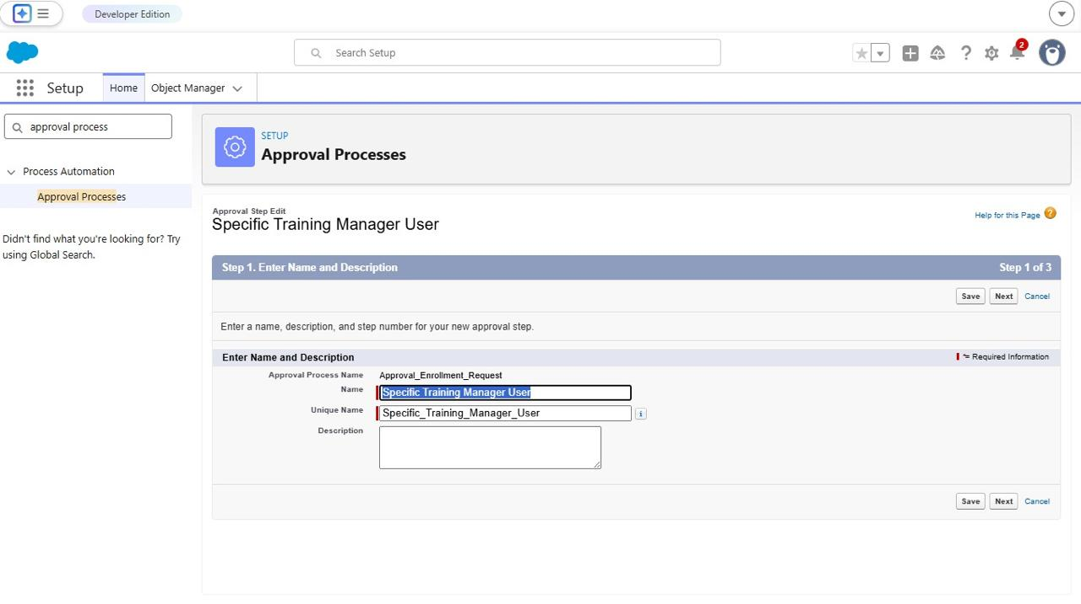
- Under Final Approval Actions:
- Add Field Update to set Enrollment_Status__c = "Approved".
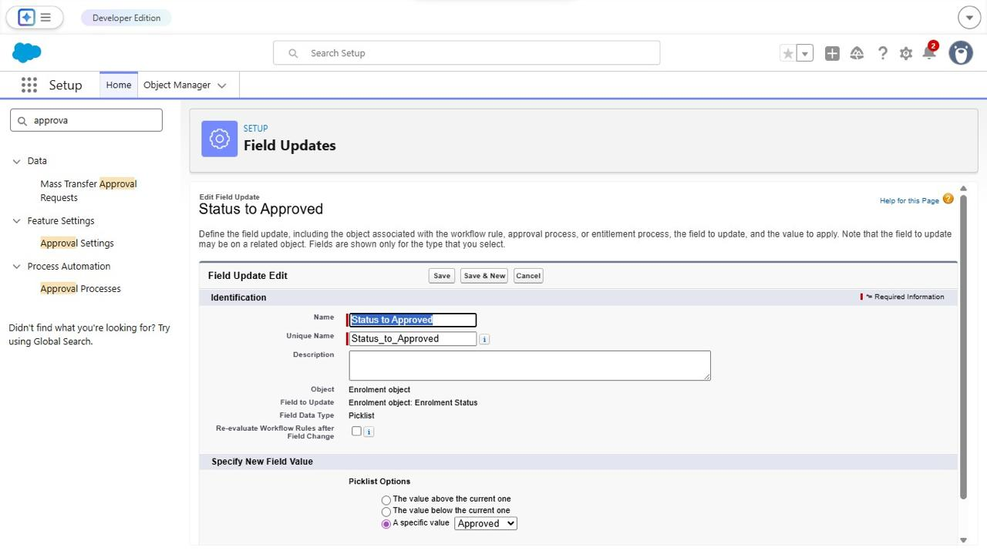
- Under Final Rejection Actions:
- Add Field Update to set Enrollment_Status__c = "Rejected".
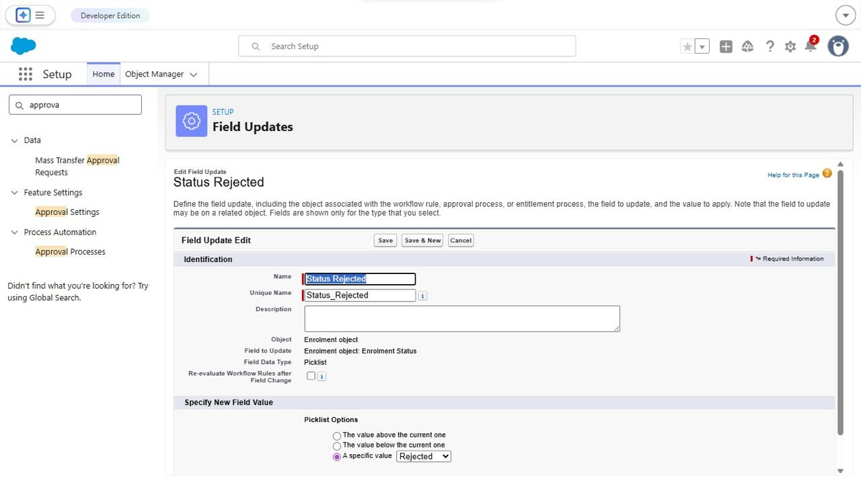
- Add Email Alert to send rejection email to student.

- Activate the approval process.

Milestone 7- Tabs

Activity 1: Creating a Tab for the Student Object:
Go to Setup.
- In the Quick Find box, type Tabs.
- Under Custom Object Tabs, click New.
- Select Student from the object list.
- Choose a tab style (icon).
- Click Next, assign it to all profiles, and then click Save.

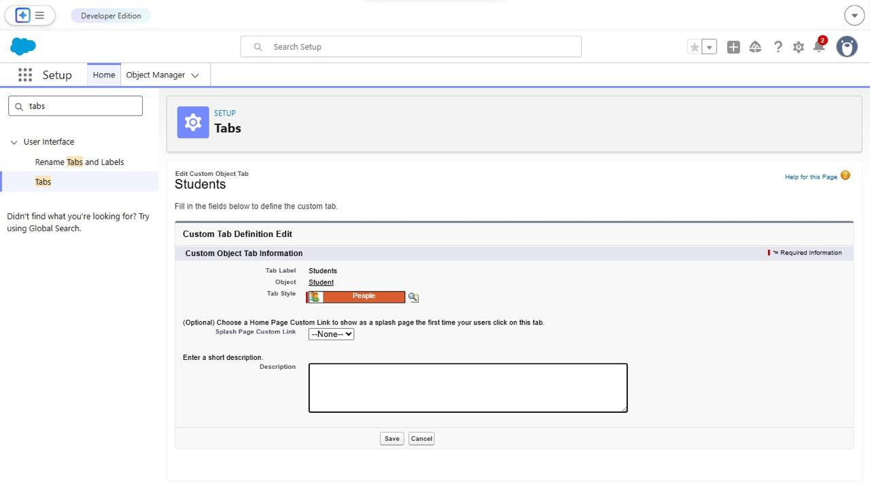

Activity 2: Creating Remaining Tabs

Now create the Tabs for the remaining Objects, they are “Courses, Instructors, Enrollment”.
Follow the same steps as mentioned in Activity -1

Milestone 8 - The Lightning App

Activity 1: Creating the Lightning Application for the Project
Navigate to Setup.

Enter App Manager in the Quick Find search box.
Click New Lightning App.
Provide the app details:
App Name: Student Enrollment & Course Management
Developer Name auto-fills
Description: Optional, but can describe the purpose of the app Click Next and choose the following settings:
App Branding (optional): Add logo or select color theme
Navigation Style: Choose Standard Navigation
Click Next and assign the app to specific profiles (e.g., Admin, Enrollment Officer, Instructor).
Click Next to select the items (tabs) to be included in the app. Add:
- Student
- Course
- Instructor
- Enrollment
- Reports
- Dashboards
- Home
- Tasks
Click Next and review the app settings.
Finally, click Save & Finish.

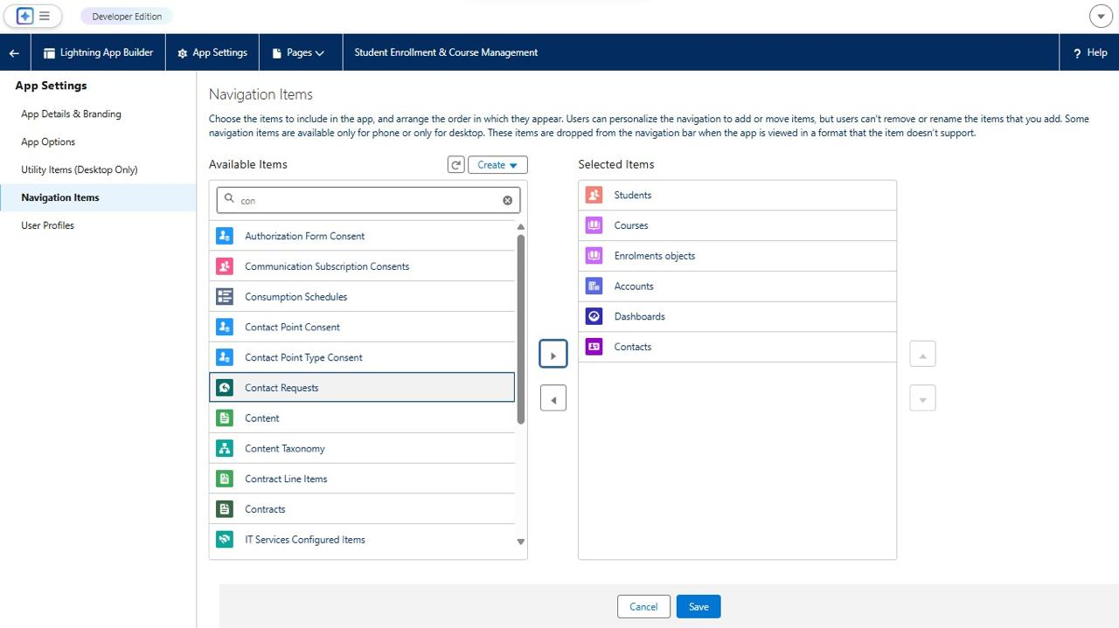
Milestone 9 – Page Layouts and Record:

Activity 1: Create Record Types for Enrollment:

Purpose:
To separate New Enrollment vs Re-Enrollment processes.
Steps:
1.Go to Setup → Object Manager → Enrollment__c.
2.Click Record Types → New.
3.For the first record type:
- Existing Record Type: Master
- Record Type Label: New Enrollment
- Enable for required profiles (Admin, Enrollment Officer). ● Select the default Page Layout → Save & New.
4.For the second record type:
- Record Type Label: Re-Enrollment ● Enable for same profiles. ● Select the default Page Layout → Save.

Activity 2: Separate Page Layo Createuts for Each Enrollment Record Type

Purpose:
To show different fields for New Enrollment vs Re-Enrollment.

Steps:

1.Enrollment__c object → click Page Layouts.
2.Click New to create a layout for New Enrollment:
- Clone from existing Enrollment Layout → name it New Enrollment Layout → Save.
- Keep fields relevant for first-time enrollment: Student, Course, Instructor, Enrollment Date, Status, Fees, etc.
- Remove unnecessary re-enrollment fields if any. ● Click Save.

3.Again, click New to create Re-Enrollment Layout:
- Clone existing layout → name it Re-Enrollment Layout → Save.
- Include fields like previous Enrollment reference (if any), ReEnrollment Reason, Status, Fees, etc. ● Click Save.
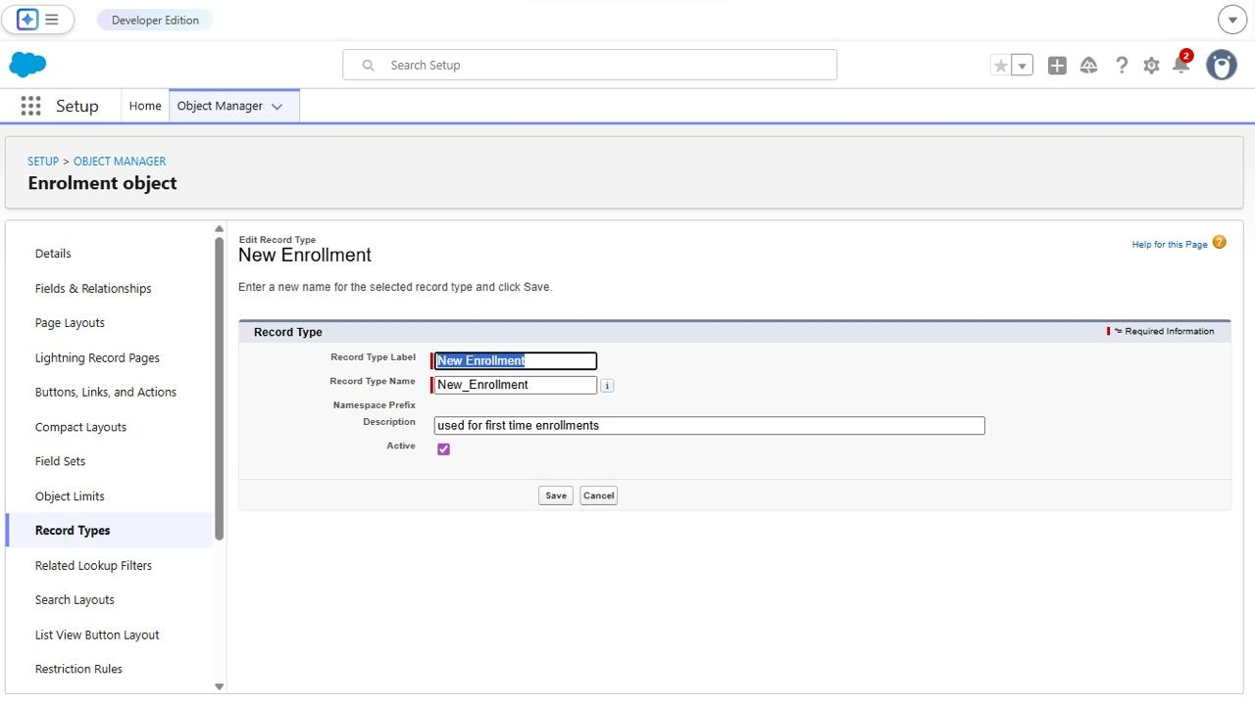

4.Click Page Layout Assignment → Edit Assignment.
5.For each profile and record type:

- New Enrollment → use New Enrollment Layout.
6.Re-Enrollment → use Re-Enrollment Layout.
Click Save.

Activity 3: Enrollment R Addelated Lists to Parent Objects:

Purpose:
To see all Enrollments from Student, Course, and Instructor records. a) Student → Enrollment Related List Go to Setup → Object Manager → Student__c.
Click Page Layouts → open the main layout. In the palette, select Related Lists.
Drag Enrollments related list onto the layout.
Customize columns if needed → Save. b) Course → Enrollment Related List
Go to Object Manager → Course__c → Page Layouts.
Open layout → add Enrollments related list.
Save.
c) Instructor → Enrollment Related List
Go to Object Manager → Instructor__c → Page Layouts.
Open layout → add Enrollments related list. Save.

Milestone 10 – Automation with Flow

Activity 1: Auto-Populate Enrollment Date (Record-Triggered Flow)

Purpose:
Set Enrollment_Date__c to today when Enrollment is created.

Steps:

  - Go to Setup → Flows → New Flow.
  - Select Record-Triggered Flow → Create.
  - Object: Enrollment__c.
  - Trigger: A record is created.
  - Optimize for Actions and Related Records → Done.
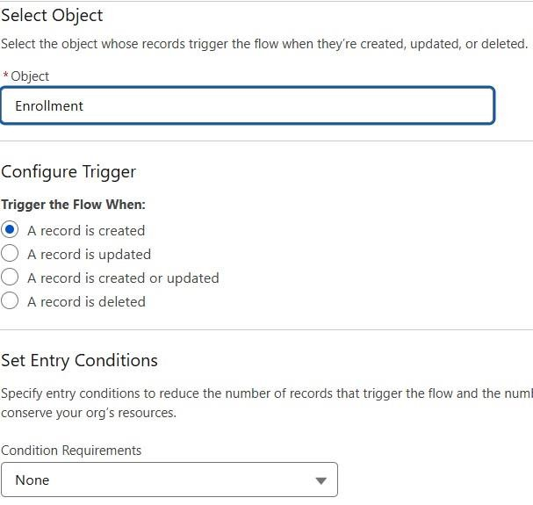
  - Add Update Records element: ● Label: Set Enrollment Date. ● Use record that triggered the flow.
● Field: Enrollment_Date__c → Value: $Flow.CurrentDate.
7.Save as SetEnrollmentDate → Activate.
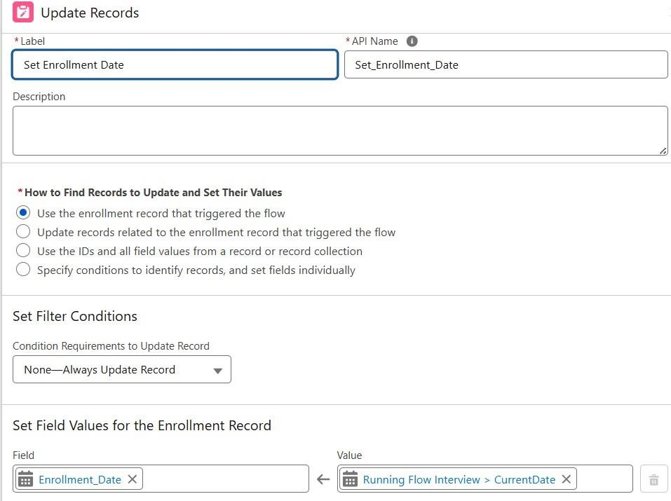

Activity 2: Send Email When Enrollment Approved

Purpose:
When Enrollment_Status__c = Approved, send email, alert admin, and set Student to Active.
Steps (high level for document):

- Create Email Template and Email Alert for student notification.

- Go to Flows → New → Record-Triggered Flow.
- Object: Enrollment__c, Trigger on update.
- Condition: Enrollment_Status__c Equals "Approved".
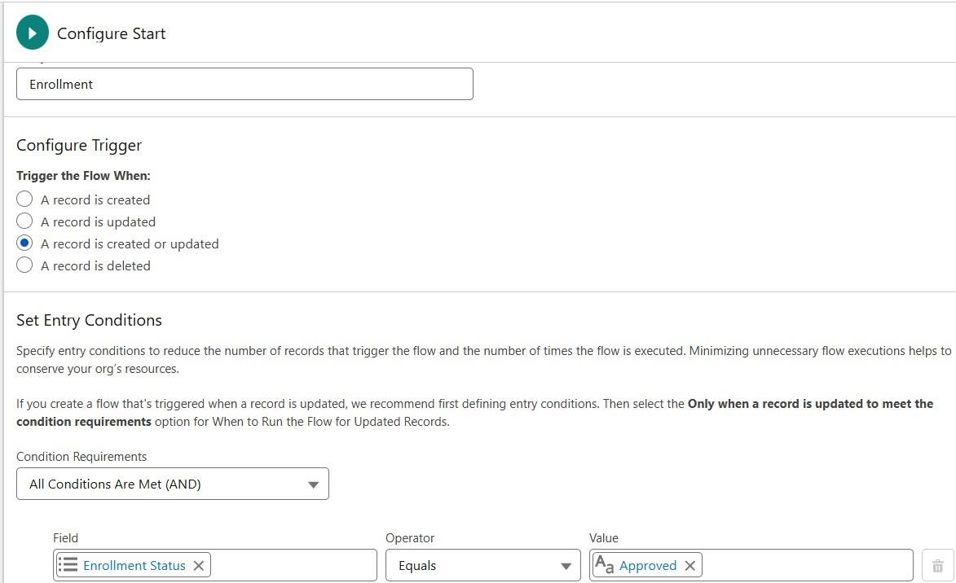
- Add Get Records to fetch related Student__c.
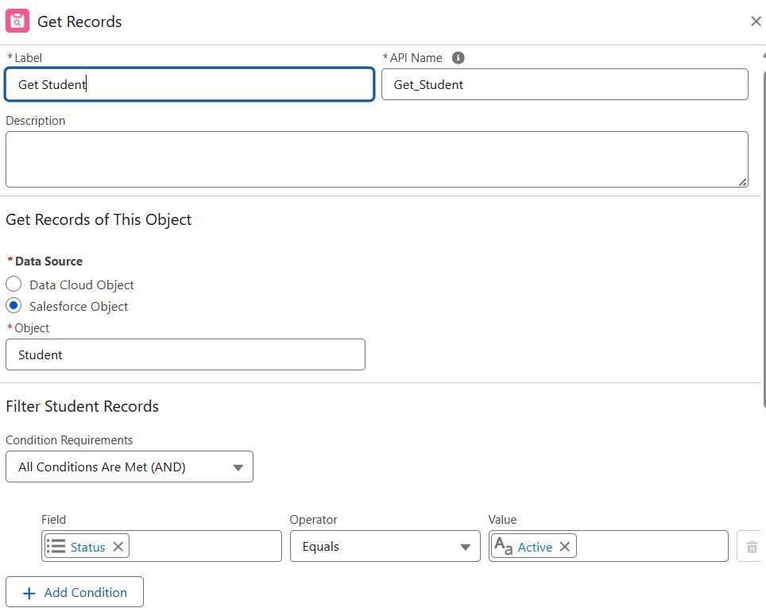
- Add Action (Email Alert) to send email to student.
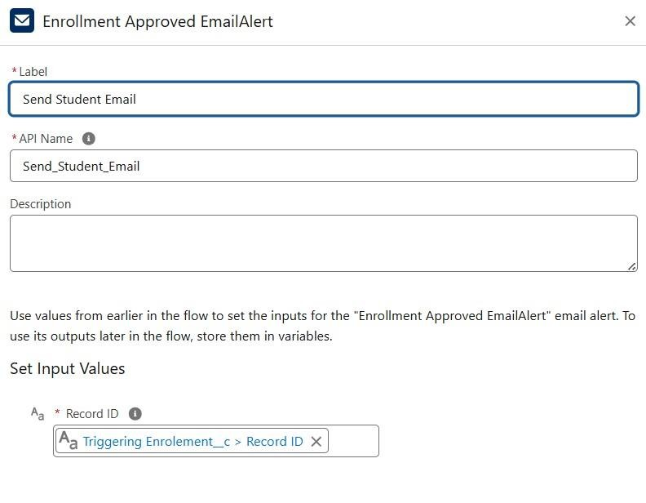
- Add Action to notify Admin if needed.
- Add Update Records to set Student__c.Status__c = "Active".
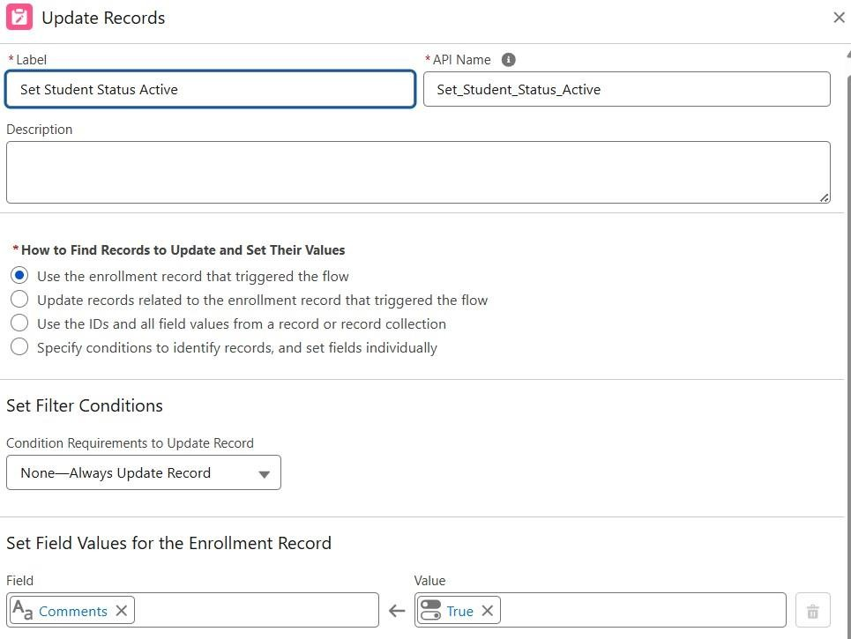
- Save as Enrollment Approved Action → Activate.

Activity 3: Auto-Assign Instructor Based on Course Category

Purpose:
Assign Instructor automatically based on Course category.

Rules:

Technical → Instructor A
Language → Instructor B Non-Technical → Instructor C Steps:

  - Prepare Instructor__c records with codes (e.g., INSTR_A, INSTR_B, INSTR_C).
  - Create Record-Triggered Flow on Enrollment__c (created/updated).
  - Add Get Records to fetch related Course__c.
  - Add Decision element on Course__r.Category__c:
  - Technical / Language / Non-Technical outcomes.
  - For each outcome:
  - Get Instructor record (A/B/C) based on code or name.
  - Update Records: set Instructor__c = Get_Instructor_X.Id.
  - Save as AutoAssign_Instructor → Activate.
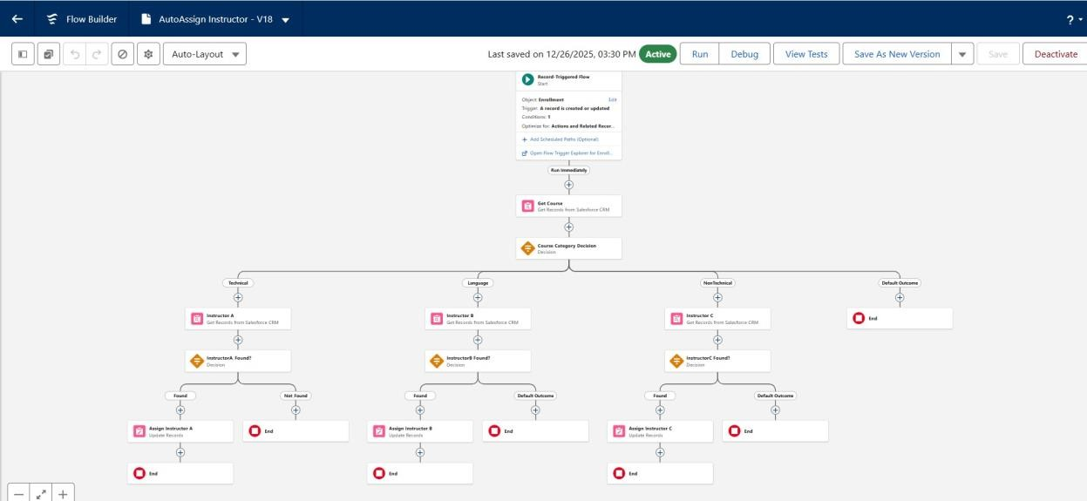

Activity 4: Auto-Create Task for Follow-Up

Purpose:
When Enrollment is “Requested”, create a follow-up task for Admin.

Steps:

- Create Record-Triggered Flow on Enrollment__c.
- Trigger: Record created or updated; condition Enrollment_Status__c = "Requested".
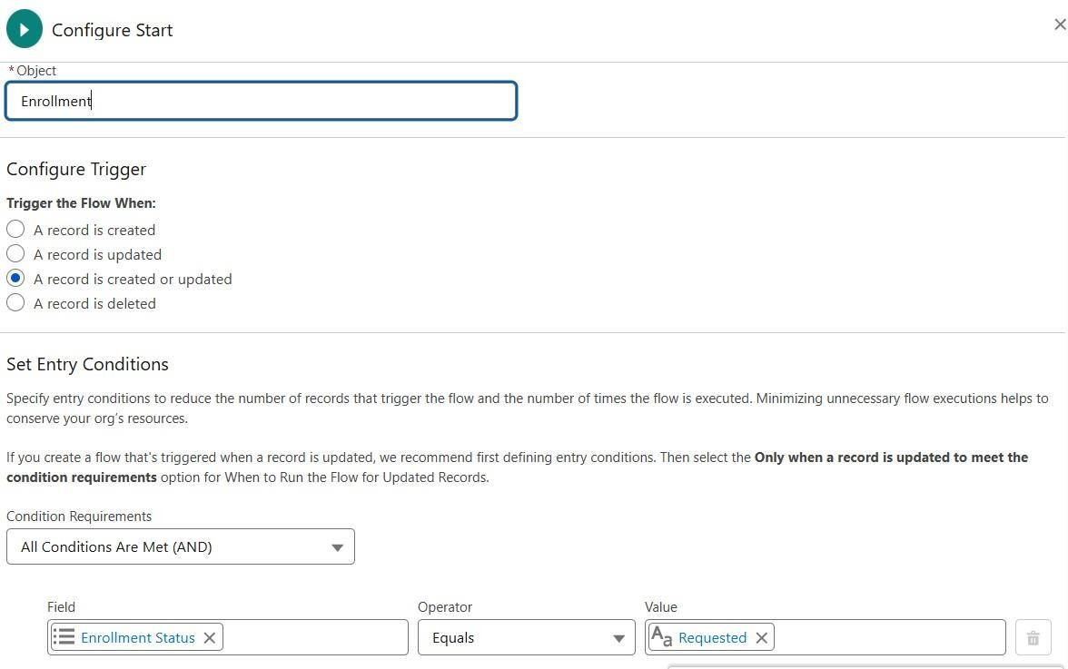
- Add Get Records to fetch Admin user (by Username / Profile).
- Add Formula (Date): TODAY() + 2 for due date.
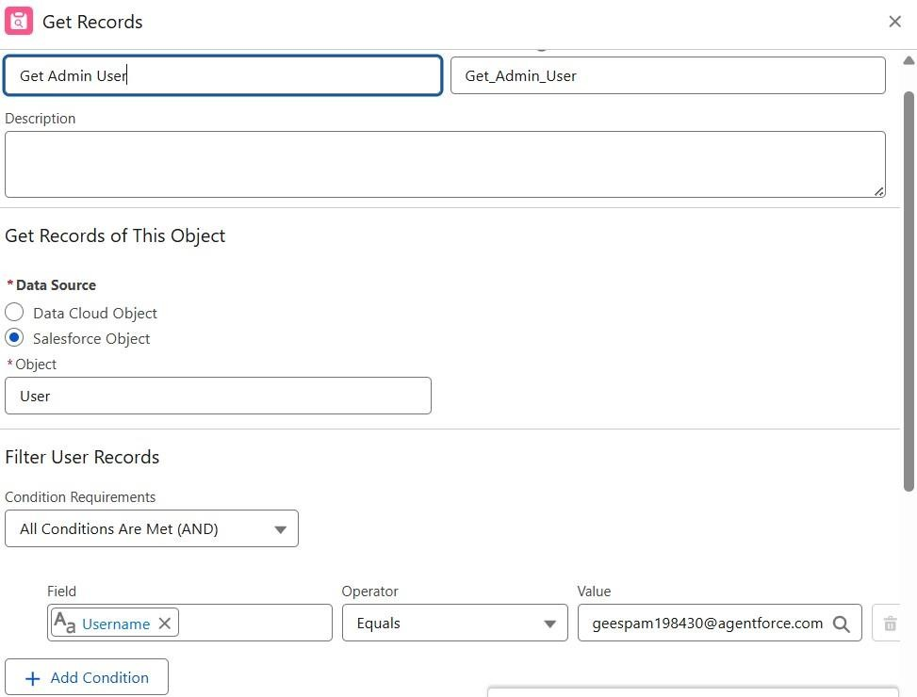
- Add Create Records for Task:
- Subject: Follow up on enrollment request.
- OwnerId: Admin user Id.
- WhatId: Enrollment Id.
- ActivityDate: formula Today + 2.
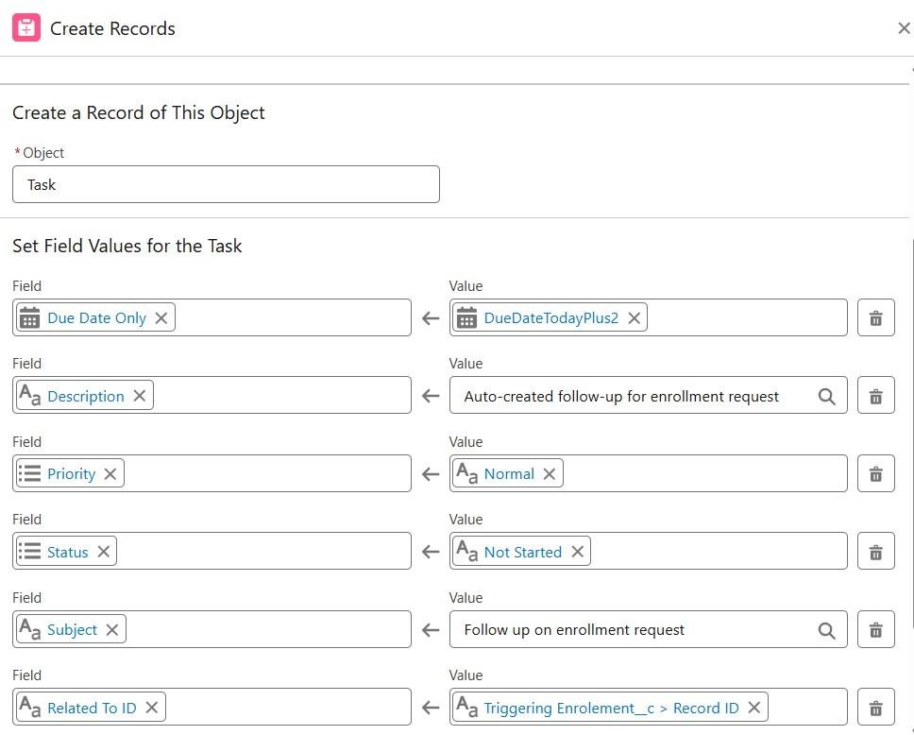
- Save as Create_Followup_Task → Activate.
Milestone 11 – Reports:
Activity 1: Create “Students by Status” Report

1.Go to Reports → New Report.
2.Report Type: Students.
3.Group rows by Status__c.
4.Add columns as needed (Name, Email, Phone).
5.Save as Students by Status.
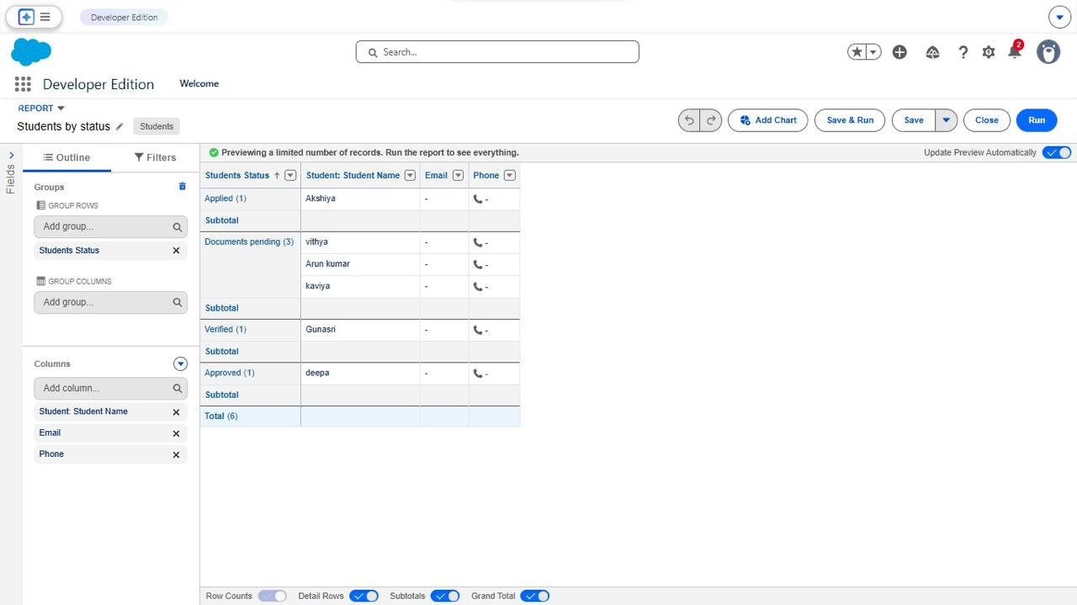

Activity 2: Create “Enrollments by Course” Report

1.New Report → Report Type: Enrollments.
2.Grouprows by Course__r.Name.
3.Show Record Count per course.
4.Save as Enrollments by Course
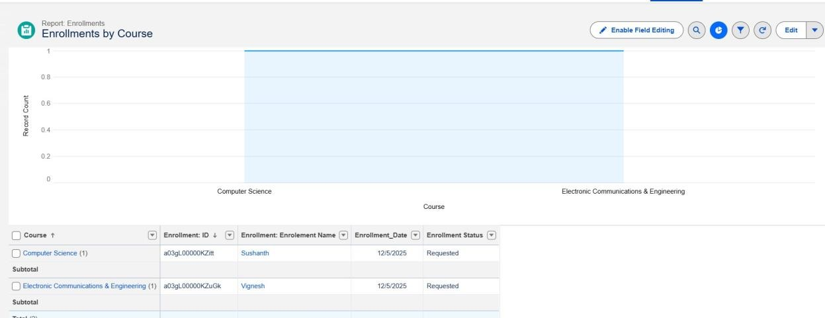

Activity 3: Create “Pending Enrollment Approvals” Report

- New Report → Enrollments report type.
- Filter: Enrollment_Status__c = "Requested".
- Add columns (Student, Course, Owner, Created Date).
- Save as Pending Enrollment Approvals.
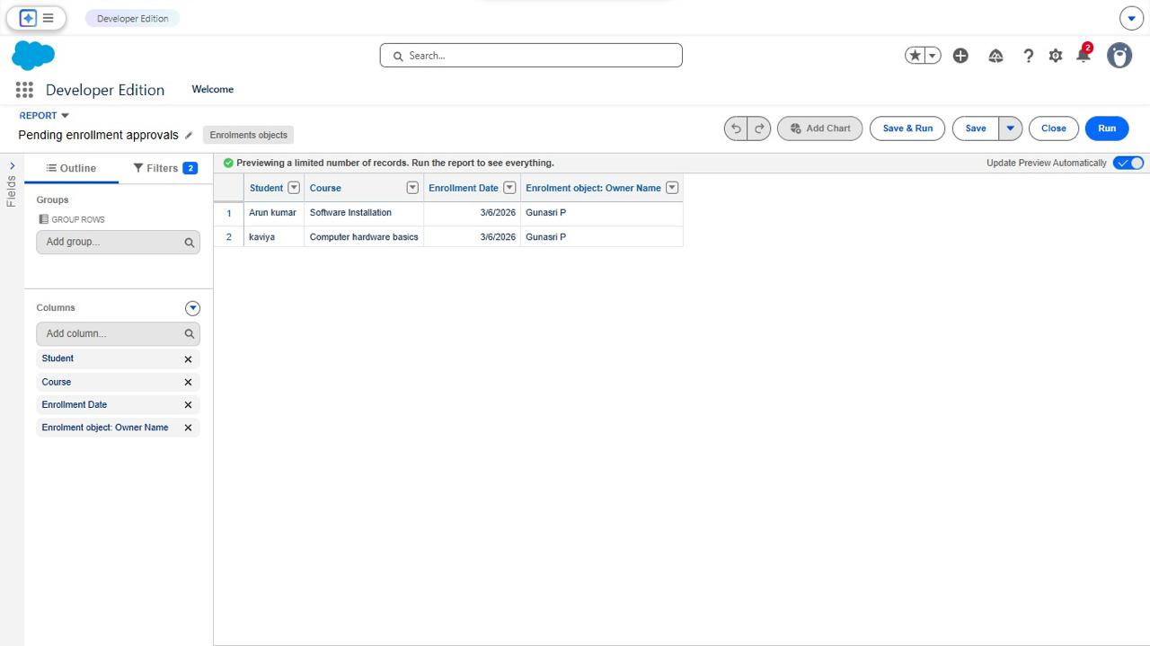
Activity 4: Create “Revenue Report (Fees Paid)” Report
1.New Report → Enrollments report type.
2.Filter: Fees_Paid__c = TRUE.
3.Group by Course__r.Name.
4.Summarize Course_Fee__c or similar fee field.
5.Save as Revenue Report – Fees Paid.
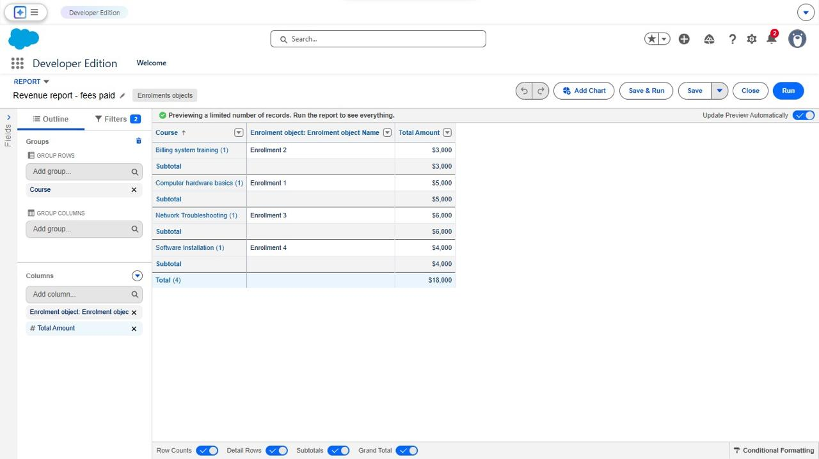
Milestone 12 – Dashboards:

Activity 1: Create “Student Managemet Dnashboard” Steps:
- Go to Dashboards → New Dashboard.
- Name: Student Management Dashboard.

- Select folder → Create.
- Select new Dashboard folder and Save.
Add components:
- Donut Chart → using Students by Status report.
- Bar Chart → using Enrollments by Course report.
- Gauge → using Revenue Report – Fees Paid (sum of revenue field).
- Table → using Pending Enrollment Approvals report.

4. Arrange components on canvas.
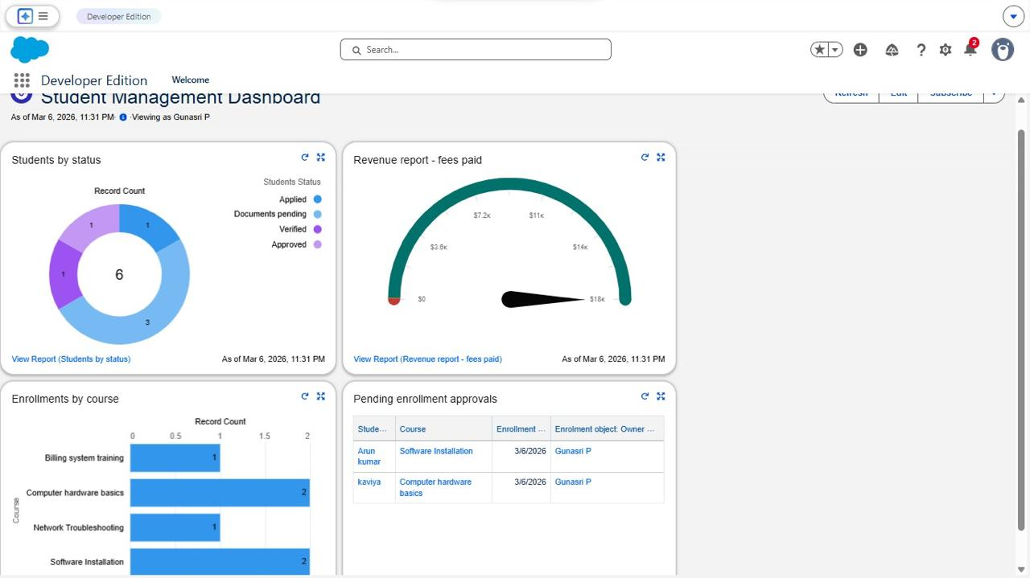
Click Save → Done.

Milestone 13 – Security Setup
Activity 1: Configure Profiles ):
1. Go to Setup → Profiles → New (or CloneProfiles Required:
- Admin – Full access.
- Enrollment Officer – Create/Update Enrollments.
- Instructor – Read-only access to assigned Enrollments.
- Steps (example for Enrollment Officer fName:
Enrollment Officer.
- In Object Settings:
○ Enrollment__c: Read, Create, Edit.
○ Student__c / Course__c: Read (and Edit if required).
- Save.

Repeat similarly for Instructor profile with Read-Only on Enrollments

Activity 2: Create Permission Sets

- Go to Setup → Permission Sets → New.
- Create Custom Object Access (additional access to project objects if needed).
- Create Dashboard Editor (Create/Customize Reports & Dashboards permissions).
- Assign to relevant users.

Activity 3: Configure Sharing & OWD Steps:
- Go to Setup → Sharing Settings.
- Set Organization-Wide Defaults:

○ Students (Student__c): Public Read/Write.
○ Courses (Course__c): Public Read/Write.
○ Enrollments (Enrollment__c): Private.
- Save.
For Instructor access to assigned Enrollments, optionally:
- Add a User lookup on Enrollment (Instructor User).
- Use a simple Record-Triggered Flow to set OwnerId = Instructor User so they can see only their own records.

7. FUNCTIONAL & PERFORMANCE TESTING

During the testing phase, screenshots were captured from the Salesforce user interface to verify the proper functioning of all implemented features of the Student Enrollment & Course Management System (SECMS). These include student, course, instructor, and enrollment record creation; validation rule checks for mandatory fields, eligibility, and enrollment constraints; verification of record type behavior for different course categories; flow execution for automated enrollment approvals and seat availability checks; and Apex trigger functionality to ensure automatic confirmation and record updates. Additionally, screenshots of generated reports and dashboards were documented to validate accurate data visualization, enrollment tracking, and performance monitoring.
Submit the Screenshots while testing.

8. ADVANTAGES & DISADVANTAGES
Advantages
- Centralized data
- Automated workflows
- Real-time reporting
Disadvantages
- Dependence on the salesforce platform
- Initia set
- Continous internet access is required
9. Conclusion:

The Student Enrollment and Course Management System developed using Salesforce provides an efficient solution for managing academic enrollment operations. The system integrates student data, course management, instructor assignment, and reporting within a single platform.

10. FUTURE SCOPE
- Payment gateway integration
- Student self-service portal
- Analytics-driven insights
- Mobile access support

11. APPENDIX
- Source Code: Salesforce Configuration
- Dataset: Salesforce Objects
- GitHub / Demo: Salesforce Developer Org

